

Tableau Workbook Name: Superstore.twbx

Background:

Requested by: |  | Requested date:

Developed by: |  | Completed date:

Audience:

Table of Contents
- General Information
  - Summary Stats
  - Data Source
  - Worksheets Mapping
  - Tables and Fields
  - Calculated Fields
  - Hierarchies
  - Parameters
  - Workbook Map
- Unused Objects in Workbook
  - Unused Fields
  - Unused Worksheets
  - Unused Calculated Fields
- Dashboards
  - Commission Model
  - Customers
  - Order Details
  - Overview
  - Product
  - Shipping
- Worksheets
  - CommissionProjection
  - CustomerOverview
  - CustomerRank
  - CustomerScatter
  - DaystoShip
  - Forecast
  - OTE
  - Performance
  - Product Detail Sheet
  - ProductDetails
  - ProductView
  - QuotaAttainment
  - Sale Map
  - Sales
  - Sales by Product
  - Sales by Segment
  - ShipSummary
  - ShippingTrend
  - Tooltip: Profit Ratio by City
  - Total Sales
  - What If Forecast

Summary Stats
 | Counts
Dashboards # | 6
Worksheets # | 21
Data Source # | 3
Data Source Filters | 0
Custom SQL # | 0
Fields # | 33
Calculated Fields # | 21
Groups # | 0
Hierarchies # | 2
Parameters # | 6
Sets # | 0
Bins # | 0
Stories # | 0

Data Source
Data Source | Data Source Type | Source | Connection Info | Joins
Sales Target | Live | excel-direct | DB: Data/Superstore/Sales Target.xlsx; File: Data/Superstore/Sales Target.xlsx | None
Sales Commission | Live | textscan | DB: Sales Commission.csv; File: Sales Commission.csv | None
Sample - Superstore | Live | excel-direct | DB: Data/Superstore/Sample - Superstore.xls; File: Data/Superstore/Sample - Superstore.xls | [Region (Orders$)] join [Region (People)] join [Order ID (Orders$)] join [Order ID (Returns)]

Worksheets Mapping
Dashboard/Storyboard Name | Worksheet Name | Object Type (Dashboard/Storyboard) | Is Used
Commission Model | QuotaAttainment | Dashboard | Yes
Commission Model | CommissionProjection | Dashboard | Yes
Commission Model | Sales | Dashboard | Yes
Commission Model | OTE | Dashboard | Yes
Customers | CustomerScatter | Dashboard | Yes
Customers | CustomerRank | Dashboard | Yes
Customers | CustomerOverview | Dashboard | Yes
Order Details | Product Detail Sheet | Dashboard | Yes
Overview | Total Sales | Dashboard | Yes
Overview | Sale Map | Dashboard | Yes
Overview | Sales by Segment | Dashboard | Yes
Overview | Sales by Product | Dashboard | Yes
Overview | Tooltip: Profit Ratio by City (Used in Sale Map as a Tooltip) | Dashboard | Yes
Product | ProductView | Dashboard | Yes
Product | ProductDetails | Dashboard | Yes
Shipping | ShipSummary | Dashboard | Yes
Shipping | ShippingTrend | Dashboard | Yes
Shipping | DaystoShip | Dashboard | Yes
N/A | Forecast | N/A | No
N/A | Performance | N/A | No
N/A | What If Forecast | N/A | No

Tables and Fields
Data Source | Source Database | Table Name | Field Name | Remote Field | Data Type | Is Used | Dimension/  Measure | Hidden
Sales Target | excel-direct | Sheet1 | Category | Category | string | No | Dimension | No
Sales Target | excel-direct | Sheet1 | Order Date | Order Date | date | No | Dimension | No
Sales Target | excel-direct | Sheet1 | Segment | Segment | string | No | Dimension | No
Sales Target | excel-direct | Sheet1 | Sales Target | Sales Target | integer | Yes | Measure | No
Sales Commission | textscan | Sales Commission.csv | Order Date | Order Date | datetime | No | Dimension | No
Sales Commission | textscan | Sales Commission.csv | Region | Region | string | No | Dimension | No
Sales Commission | textscan | Sales Commission.csv | Sales Person | Sales Person | string | Yes | Dimension | No
Sales Commission | textscan | Sales Commission.csv | Sales | Sales | integer | Yes | Measure | No
Sample - Superstore | excel-direct | Orders | Row ID | Row ID | integer | No | Dimension | No
Sample - Superstore | excel-direct | Orders | Order ID | Order ID | string | Yes | Dimension | No
Sample - Superstore | excel-direct | Orders | Order Date | Order Date | date | Yes | Dimension | No
Sample - Superstore | excel-direct | Orders | Ship Date | Ship Date | date | Yes | Dimension | No
Sample - Superstore | excel-direct | Orders | Ship Mode | Ship Mode | string | Yes | Dimension | No
Sample - Superstore | excel-direct | Orders | Customer ID | Customer ID | string | No | Dimension | No
Sample - Superstore | excel-direct | Orders | Customer Name | Customer Name | string | Yes | Dimension | No
Sample - Superstore | excel-direct | Orders | Segment | Segment | string | Yes | Dimension | No
Sample - Superstore | excel-direct | Orders | Country/Region | Country/Region | string | Yes | Dimension | No
Sample - Superstore | excel-direct | Orders | City | City | string | Yes | Dimension | No
Sample - Superstore | excel-direct | Orders | State/Province | State/Province | string | Yes | Dimension | No
Sample - Superstore | excel-direct | Orders | Postal Code | Postal Code | string | Yes | Dimension | No
Sample - Superstore | excel-direct | Orders | Region | Region | string | Yes | Dimension | No
Sample - Superstore | excel-direct | Orders | Product ID | Product ID | string | No | Dimension | No
Sample - Superstore | excel-direct | Orders | Category | Category | string | Yes | Dimension | No
Sample - Superstore | excel-direct | Orders | Sub-Category | Sub-Category | string | Yes | Dimension | No
Sample - Superstore | excel-direct | Orders | Product Name | Product Name | string | Yes | Dimension | No
Sample - Superstore | excel-direct | Orders | Sales | Sales | real | Yes | Measure | No
Sample - Superstore | excel-direct | Orders | Quantity | Quantity | integer | Yes | Measure | No
Sample - Superstore | excel-direct | Orders | Discount | Discount | real | Yes | Measure | No
Sample - Superstore | excel-direct | Orders | Profit | Profit | real | Yes | Measure | No
Sample - Superstore | excel-direct | People | Regional Manager | Regional Manager | string | No | Dimension | No
Sample - Superstore | excel-direct | People | Region (People) | Region | string | No | Dimension | Yes
Sample - Superstore | excel-direct | Returns | Order ID (Returns) | Order ID | string | No | Dimension | Yes
Sample - Superstore | excel-direct | Returns | Returned | Returned | string | No | Dimension | No

Calculated Fields
Calculated Field Name | Tableau Field Name | Data Source | Formula | Is Used | Dimension/  Measure
Achievement (estimated) | Achievement (copy) | Sales Commission | [Sales] | Yes | Measure
Achieved Quota | Achievement (variable) (copy) | Sales Commission | if SUM([Achievement (estimated)]) >= [New Quota] then "100% +"  elseif SUM([Achievement (estimated)]) >= 0.75 * [Parameters].[New Quota] then "75-100%"  elseif SUM([Achievement (estimated)]) >= 0.5 * [Parameters].[New Quota] then "50-75%"  else "Below 50%" end | Yes | Measure
Base (Variable) | Base (Variable) | Sales Commission | [Base Salary] | Yes | Measure
% of quota achieved | Calculation_0440925131659539 | Sales Commission | AVG([Achievement (estimated)])/[New Quota] | Yes | Measure
Rank over 3 | Calculation_4120925132203686 | Sales Commission | ROUND(INDEX() / 3 - 0.6,0) + 1 | Yes | Measure
Sort by field | Calculation_8140925133029303 | Sales Commission | if [Sort by]="Names" then 0  elseif [Parameters].[Sort by]="% quota descending" then -[% of quota achieved]  else [% of quota achieved] end | Yes | Measure
Commission (Variable) | Commission (Variable) | Sales Commission | ([Commission Rate]*[Sales])/100 | Yes | Measure
Estimate Compensation label | Estimate Compensation label | Sales Commission | "Estimated Compensation:" | No | Dimension
OTE (Variable) | OTE (Variable) | Sales Commission | [Base Salary] + ([Parameters].[Commission Rate]*[Parameters].[New Quota])/100 | Yes | Measure
Total Compensation | Total Compensation | Sales Commission | MIN([Base (Variable)]) + SUM([Commission (Variable)]) | Yes | Measure
Total Sales label | Total Sales label | Sales Commission | "Total Sales:" | No | Dimension
Days to Ship Actual | Calculation_0831103151444568 | Sample - Superstore | DATEDIFF('day',[Order Date],[Ship Date]) | Yes | Measure
Sales Forecast | Calculation_5421109230915137 | Sample - Superstore | [Sales]*(1-[Churn Rate])*(1+[Parameters].[New Business Growth]) | Yes | Measure
Ship Status | Calculation_6401103171259723 | Sample - Superstore | if [Days to Ship Actual]> [Days to Ship Scheduled] then "Shipped Late"  elseIF [Days to Ship Actual]= [Days to Ship Scheduled] then "Shipped On Time"  Else "Shipped Early" end | Yes | Dimension
Days to Ship Scheduled | Calculation_6861103170623145 | Sample - Superstore | CASE [Ship Mode]  WHEN "Same Day" THEN 0  WHEN "First Class" THEN 1  WHEN "Second Class" THEN 3  WHEN "Standard Class" THEN 6  END | Yes | Measure
Order Profitable? | Calculation_9060122104947471 | Sample - Superstore | {fixed [Order ID]:sum([Profit])}>0  // calculates the profit at the order level | Yes | Dimension
Sales per Customer | Calculation_9321103144526191 | Sample - Superstore | Sum([Sales])/countD([Customer Name]) | Yes | Measure
Profit Ratio | Calculation_9921103144103743 | Sample - Superstore | sum([Profit])/sum([Sales]) | Yes | Measure
Sales above Target? | Calculation_9951107165644870 | Sample - Superstore | If Sum([Sales])>SUM([Sales Target].[Sales Target]) then "Above Target" else "Below Target" end | Yes | Measure
Units estimate | Sales est (copy) | Sample - Superstore | ROUND([Quantity]*(1-[Churn Rate])*(1+[Parameters].[New Business Growth]),0) | Yes | Measure
Profit per Order | Sales per Customer (copy) | Sample - Superstore | Sum([Profit])/countD([Order ID]) | Yes | Measure

Hierarchies
Hierarchy Name | Data Source | Fields | Is Used
Location | Sample - Superstore | Country/Region, Region, State/Province, City, Postal Code | Yes
Product | Sample - Superstore | Category, Sub-Category, Product Name | Yes

Parameters
Parameter Name | Data Type | Allowable Value type | Current Value | Values | Is Used
Base Salary | Integer | Range | 50000 | Min: 0, Step size: 1000 | Yes
Commission Rate | Float | Range | 18.4% | Min: 1.0%, Max: 100.0%, Step size: 0.1% | Yes
New Quota | Integer | Range | 500000 | Min: 100000, Step size: 25000 | Yes
Sort by | String | List | Names | % quota ascending, % quota descending, Names | Yes
New Business Growth | Float | Range | 60% | Min: 0%, Max: 100%, Step size: 1% | Yes
Churn Rate | Float | Range | 6.40% | Min: 0.00%, Max: 25.00%, Step size: 0.10% | Yes

Workbook Map
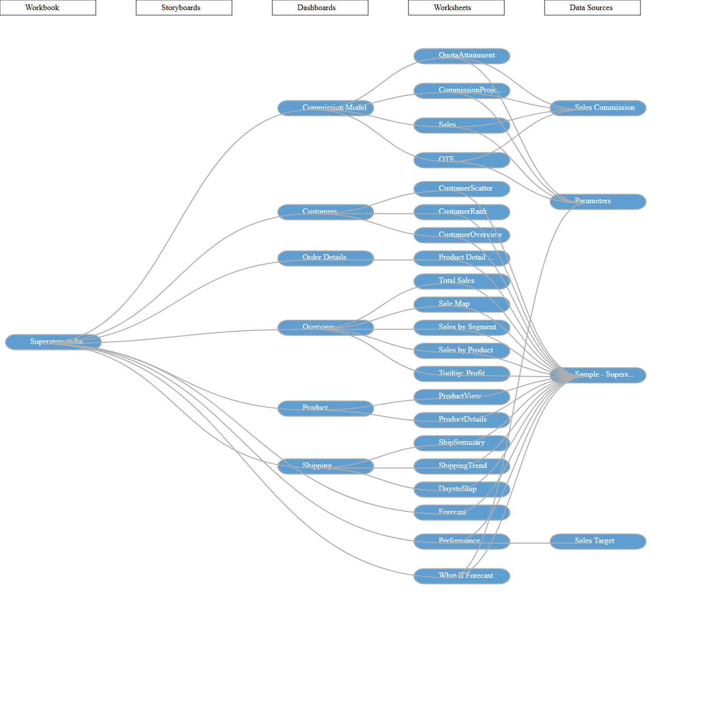

Unused Objects in Workbook

Unused Fields
Data Source | Field Name
Sales Target | Category
Sales Target | Order Date
Sales Target | Segment
Sales Commission | Order Date
Sales Commission | Region
Sample - Superstore | Row ID
Sample - Superstore | Customer ID
Sample - Superstore | Product ID
Sample - Superstore | Regional Manager
Sample - Superstore | Region (People)
Sample - Superstore | Order ID (Returns)
Sample - Superstore | Returned

Unused Worksheets
- Forecast
- Performance
- What If Forecast

Unused Calculated Fields
Data Source | Calculated Field Name
Sales Commission | Estimate Compensation label
Sales Commission | Total Sales label

Dashboards

Dashboard Name: Commission Model
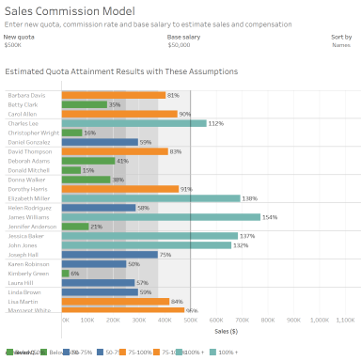

"Commission Model" Summary Stats
 | Counts
Worksheets # | 4
Parameters # | 4
Quick Filters # | 0
Actions # | 1

Below Worksheets were used in "Commission Model" Dashboard
- QuotaAttainment
- CommissionProjection
- Sales
- OTE

Parameters used
- Base Salary
- Commission Rate
- New Quota
- Sort by

Actions
Action Name | Action Type | Source Sheet | Target Sheet | Run Action On | Target Filter
Highlight 3 (generated) 1 | Highlight | QuotaAttainment, CommissionProjection, Sales, OTE | QuotaAttainment, CommissionProjection | on-select | Selected (Sales Person)
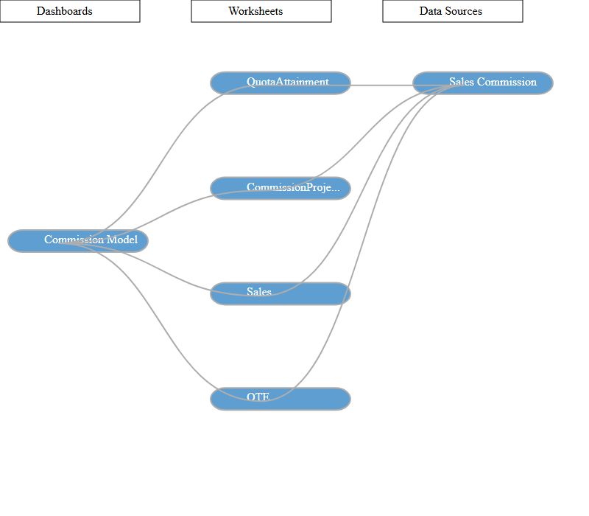

Dashboard Name: Customers
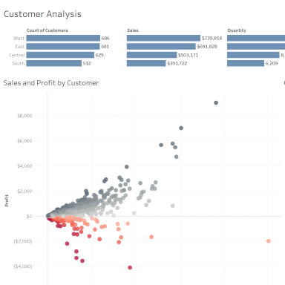

"Customers" Summary Stats
 | Counts
Worksheets # | 3
Parameters # | 0
Quick Filters # | 3
Actions # | 3

Below Worksheets were used in "Customers" Dashboard
- CustomerScatter
- CustomerRank
- CustomerOverview

Quick Filters Applied
Field Name | Sheet Name | Apply to
Order Date | CustomerOverview, CustomerRank, CustomerScatter, DaystoShip, Performance, ProductDetails, ProductView, ShipSummary, ShippingTrend, What If Forecast | Selected
Category | CustomerOverview, CustomerRank, CustomerScatter, Product Detail Sheet, ProductView | Selected
Segment | CustomerOverview, CustomerRank, CustomerScatter, Product Detail Sheet | Selected

Actions
Action Name | Action Type | Source Sheet | Target Sheet | Run Action On | Target Filter
Highlight Customer Name (Hover) 1 | Highlight | CustomerScatter, CustomerRank | CustomerScatter, CustomerRank | on-hover | Selected (Customer Name)
Filter Region 1 | Filter | CustomerOverview | CustomerScatter, CustomerRank | on-select | Selected (Region)
Highlight 1 (generated) 1 | Highlight | CustomerScatter, CustomerRank | CustomerScatter, CustomerRank | on-select | all
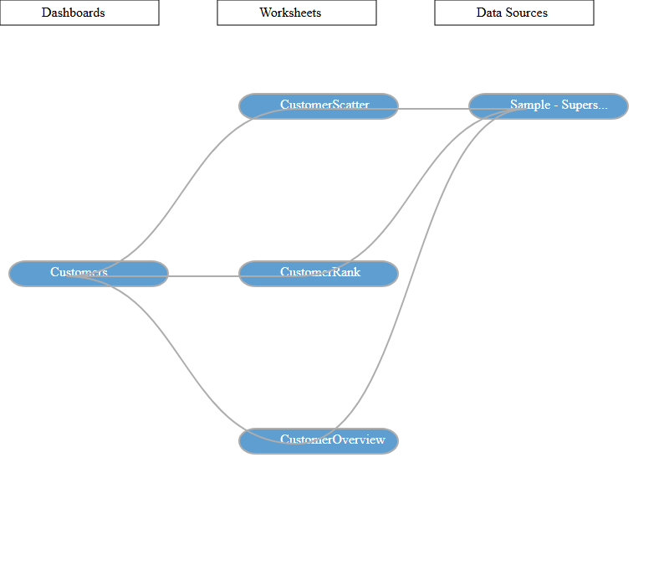

Dashboard Name: Order Details
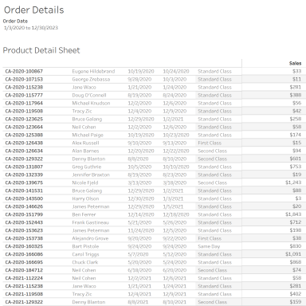

"Order Details" Summary Stats
 | Counts
Worksheets # | 1
Parameters # | 0
Quick Filters # | 6
Actions # | 0

Below Worksheets were used in "Order Details" Dashboard
- Product Detail Sheet

Quick Filters Applied
Field Name | Sheet Name | Apply to
Order Date | CustomerOverview, CustomerRank, CustomerScatter, Forecast, Product Detail Sheet, ProductDetails, Sale Map, Sales by Product, Sales by Segment, Tooltip: Profit Ratio by City, Total Sales, What If Forecast | Selected
Region | CustomerOverview, CustomerRank, CustomerScatter, DaystoShip, Forecast, Performance, Product Detail Sheet, ProductDetails, ProductView, Sale Map, Sales by Product, Sales by Segment, ShipSummary, ShippingTrend, Total Sales, What If Forecast | Selected
State/Province | Product Detail Sheet | All
City | Product Detail Sheet | All
Category | CustomerOverview, CustomerRank, CustomerScatter, Product Detail Sheet, ProductView | Selected
Segment | CustomerOverview, CustomerRank, CustomerScatter, Product Detail Sheet | Selected
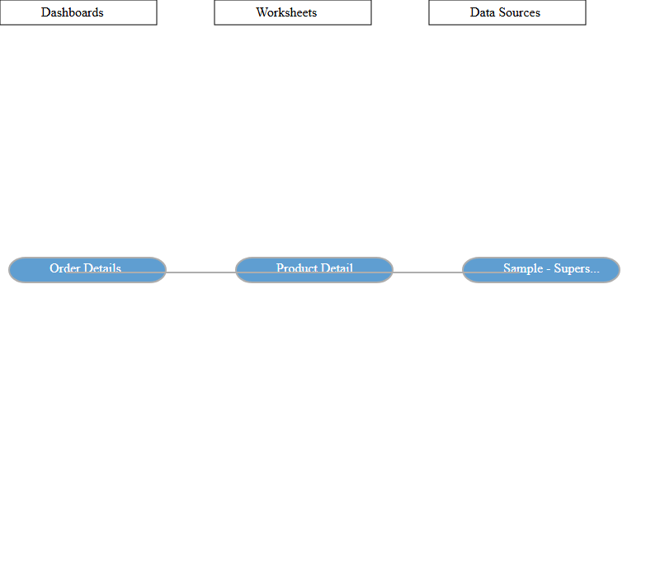

Dashboard Name: Overview
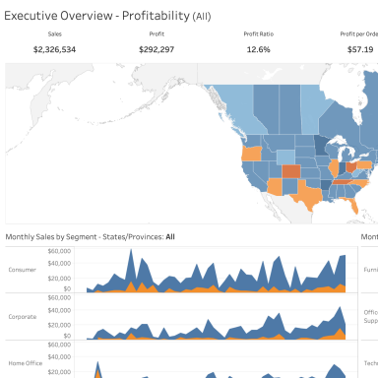

"Overview" Summary Stats
 | Counts
Worksheets # | 4
Parameters # | 0
Quick Filters # | 3
Actions # | 3

Below Worksheets were used in "Overview" Dashboard
- Total Sales
- Sale Map
- Sales by Segment
- Sales by Product

Quick Filters Applied
Field Name | Sheet Name | Apply to
Region | CustomerOverview, CustomerRank, CustomerScatter, DaystoShip, Forecast, Performance, Product Detail Sheet, ProductDetails, ProductView, Sale Map, Sales by Product, Sales by Segment, ShipSummary, ShippingTrend, Total Sales, What If Forecast | Selected
Order Date | CustomerOverview, CustomerRank, CustomerScatter, Forecast, Product Detail Sheet, ProductDetails, Sale Map, Sales by Product, Sales by Segment, Tooltip: Profit Ratio by City, Total Sales, What If Forecast | Selected
Profit Ratio | Sale Map | Only this

Actions
Action Name | Action Type | Source Sheet | Target Sheet | Run Action On | Target Filter
State/Province Filter 1 | Filter | Sale Map | Total Sales, Sales by Segment, Sales by Product | on-select | Selected (State/Province)
State/Province Highlight (map) 1 | Highlight | Total Sales, Sale Map | Total Sales, Sale Map | on-select | Selected (State/Province)
Month Highlight 1 | Highlight | Total Sales, Sales by Segment, Sales by Product | Total Sales, Sales by Segment, Sales by Product | on-select | Selected (MONTH(Order Date),Order Profitable?)
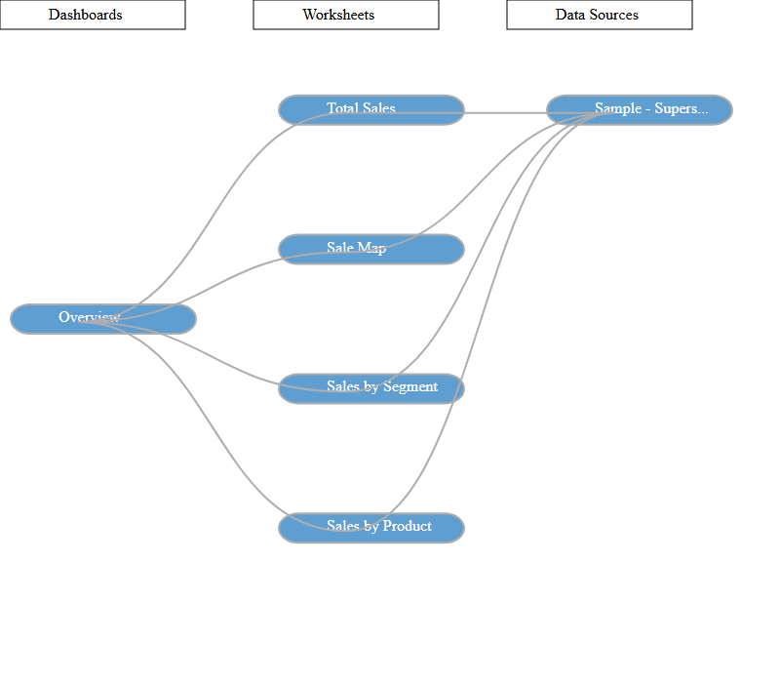

Dashboard Name: Product
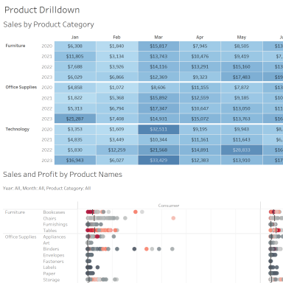

"Product" Summary Stats
 | Counts
Worksheets # | 2
Parameters # | 0
Quick Filters # | 1
Actions # | 1

Below Worksheets were used in "Product" Dashboard
- ProductView
- ProductDetails

Quick Filters Applied
Field Name | Sheet Name | Apply to
Region | CustomerOverview, CustomerRank, CustomerScatter, DaystoShip, Forecast, Performance, Product Detail Sheet, ProductDetails, ProductView, Sale Map, Sales by Product, Sales by Segment, ShipSummary, ShippingTrend, Total Sales, What If Forecast | Selected

Actions
Action Name | Action Type | Source Sheet | Target Sheet | Run Action On | Target Filter
Filter Product Sales 1 | Filter | ProductView | ProductView, ProductDetails | on-select | All
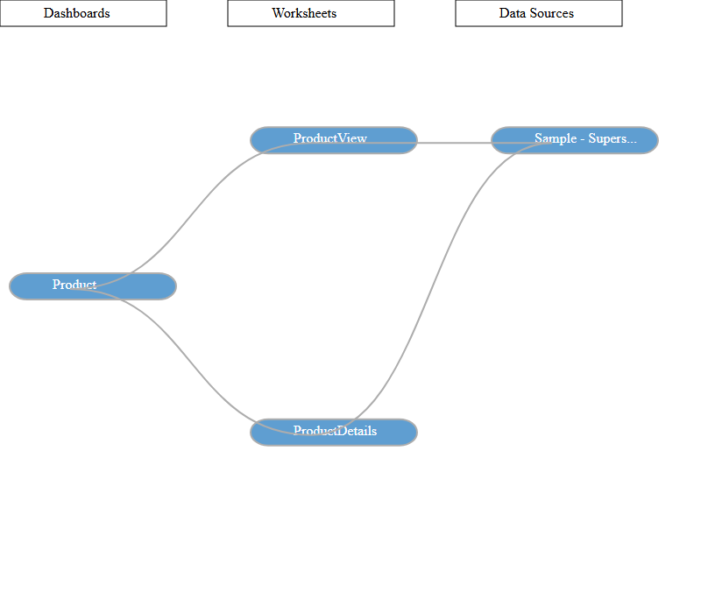

Dashboard Name: Shipping
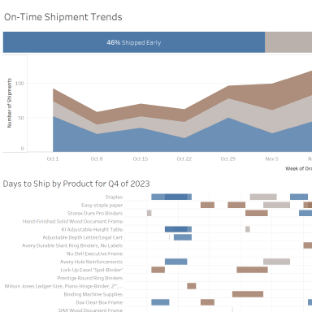

"Shipping" Summary Stats
 | Counts
Worksheets # | 3
Parameters # | 0
Quick Filters # | 3
Actions # | 2

Below Worksheets were used in "Shipping" Dashboard
- ShipSummary
- ShippingTrend
- DaystoShip

Quick Filters Applied
Field Name | Sheet Name | Apply to
Order Date | CustomerOverview, CustomerRank, CustomerScatter, DaystoShip, Performance, ProductDetails, ProductView, ShipSummary, ShippingTrend, What If Forecast | Selected
Region | CustomerOverview, DaystoShip, ShipSummary, ShippingTrend | Selected
Ship Mode | CustomerOverview, CustomerRank, CustomerScatter, DaystoShip, Forecast, Performance, Product Detail Sheet, ProductDetails, ProductView, Sale Map, Sales by Product, Sales by Segment, ShipSummary, ShippingTrend, Total Sales, What If Forecast | Selected

Actions
Action Name | Action Type | Source Sheet | Target Sheet | Run Action On | Target Filter
Filter Details 1 | Filter | ShippingTrend | ShippingTrend, DaystoShip | on-select | All
Filter 1 (generated) 1 | Filter | ShipSummary | ShipSummary, ShippingTrend, DaystoShip | on-select | All
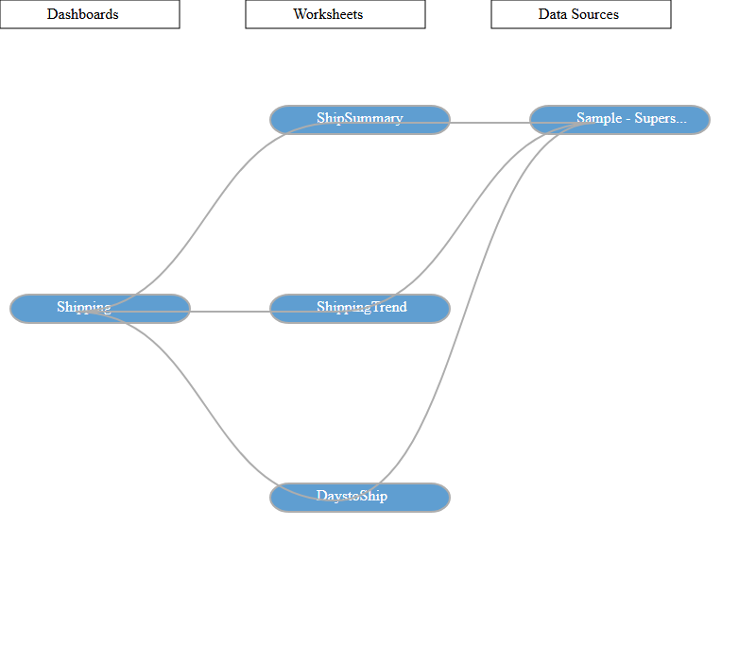

Worksheets

Worksheet Name: CommissionProjection

Worksheet was used in the following Dashboards
- Commission Model

Data Sources
Data Source | Data Source Type | Source | Joins
Sales Commission | Live | textscan | None

Filters
Field Name | Field Selection | Field Wildcard | Field Condition | Field Limit | Context Filter
Measure Names Sum(Commission ) | Selected from list | All | None | None | No
Measure Names Min(Base ) | Selected from list | All | None | None | No

Marks
Object(s) Used | Mark Type
Measure Names | Color
Sum (Achievement (estimated)) | Detail
Custom (Total Compensation) | Detail
Maximum (OTE (Variable)) | Detail
Custom (Total Compensation) | Detail
Custom (Achieved Quota) | Detail

Calculated Fields
Field Name | Formula
Achievement (estimated) | [Sales]
Achieved Quota | if SUM([Achievement (estimated)]) >= [New Quota] then "100% +"  elseif SUM([Achievement (estimated)]) >= 0.75 * [New Quota] then "75-100%"  elseif SUM([Achievement (estimated)]) >= 0.5 * [Parameters].[New Quota] then "50-75%"  else "Below 50%" end
Base (Variable) | [Base Salary]
% of quota achieved | AVG([Achievement (estimated)])/[New Quota]
Rank over 3 | ROUND(INDEX() / 3 - 0.6,0) + 1
Sort by field | if [Sort by]="Names" then 0  elseif [Sort by]="% quota descending" then -[% of quota achieved]  else [% of quota achieved] end
Commission (Variable) | ([Commission Rate]*[Sales])/100
OTE (Variable) | [Base Salary] + ([Commission Rate]*[Parameters].[New Quota])/100
Total Compensation | MIN([Base (Variable)]) + SUM([Commission (Variable)])

Columns and Rows
Field Name | Column/Row
Custom (Rank over 3) | Rows
Sales Person | Rows
Measure Values | Columns

Applied Sortings
Field Name | Sort By | Sort Order | Aggregation Field | Aggregation Type
Sales Person | Field | Ascending | Sort by field | Custom
Measure Names | Manual | NA | NA | NA
Achieved Quota | Manual | NA | NA | NA

Worksheet Name: CustomerOverview

Worksheet was used in the following Dashboards
- Customers

Data Sources
Data Source | Data Source Type | Source | Joins
Sample - Superstore | Live | excel-direct | [Region (Orders$)] join [Region (People)] join [Order ID (Orders$)] join [Order ID (Returns)]

Filters
Field Name | Field Selection | Selected Field Value(s) | Field Wildcard | Field Condition | Field Limit | Context Filter
Measure Names CountD(Customer Name) | Selected from list |  | All | None | None | No
Measure Names Sum(Sales) | Selected from list |  | All | None | None | No
Measure Names Sum(Quantity) | Selected from list |  | All | None | None | No
Measure Names (Sales per Customer) | Selected from list |  | All | None | None | No
Measure Names Sum(Profit) | Selected from list |  | All | None | None | No
Measure Names (Profit Ratio) | Selected from list |  | All | None | None | No
Category | Use all |  | All | None | None | No
Order Date | In-Range | From 2023-01-03 to 2026-12-30 | All | None | max[#2026-12-30#], min[#2023-01-03#] | No
Region | Use all |  | All | None | None | No
Segment | Use all |  | All | None | None | No
Order Date | Selected from list | None | All | None | None | No
Order Date | Use all |  | All | None | None | No

Actions
Action Name | Source Sheet | Target Sheet | Run Action On | Target Filter
Filter Region 1 | CustomerOverview | CustomerScatter, CustomerRank | on-select | Selected (Region)

Marks
Object(s) Used | Mark Type
Count (Distinct) (Customer Name) | Detail
Sum (Sales) | Detail
Sum (Quantity) | Detail
Custom (Sales per Customer) | Detail
Sum (Profit) | Detail
Custom (Profit Ratio) | Detail

Calculated Fields
Field Name | Formula
Days to Ship Actual | DATEDIFF('day',[Order Date],[Ship Date])
Days to Ship Scheduled | CASE [Ship Mode]  WHEN "Same Day" THEN 0  WHEN "First Class" THEN 1  WHEN "Second Class" THEN 3  WHEN "Standard Class" THEN 6  END
Sales per Customer | Sum([Sales])/countD([Customer Name])
Profit Ratio | sum([Profit])/sum([Sales])

Columns and Rows
Field Name | Column/Row
Region | Rows
Measure Names | Columns
Measure Values | Columns

Applied Sortings
Field Name | Sort By | Sort Order | Aggregation Field | Aggregation Type
Region | Field | Descending | Customer Name | Count (Distinct)
Measure Names | Manual | NA | NA | NA

Worksheet Name: CustomerRank

Worksheet was used in the following Dashboards
- Customers

Data Sources
Data Source | Data Source Type | Source | Joins
Sample - Superstore | Live | excel-direct | [Region (Orders$)] join [Region (People)] join [Order ID (Orders$)] join [Order ID (Returns)]

Filters
Field Name | Field Selection | Selected Field Value(s) | Field Wildcard | Field Condition | Field Limit | Context Filter
Action (Region) | Use all |  | All | None | None | No
Category | Use all |  | All | None | None | No
Order Date | In-Range | From 2023-01-03 to 2026-12-30 | All | None | max[#2026-12-30#], min[#2023-01-03#] | No
Region | Use all |  | All | None | None | No
Segment | Use all |  | All | None | None | No
Order Date | Use all |  | All | None | None | No

Actions
Action Name | Source Sheet | Target Sheet | Run Action On | Target Filter
Highlight Customer Name (Hover) 1 | CustomerScatter, CustomerRank | CustomerScatter, CustomerRank | on-hover | Selected (Customer Name)
Highlight 1 (generated) 1 | CustomerScatter, CustomerRank | CustomerScatter, CustomerRank | on-select | all

Marks
Object(s) Used | Mark Type
Custom (Profit Ratio) | Color
Sum (Profit) | Tooltip
Sum (Sales) | Detail

Calculated Fields
Field Name | Formula
Profit Ratio | sum([Profit])/sum([Sales])

Columns and Rows
Field Name | Column/Row
Customer Name | Rows
Sum (Sales) | Columns

Applied Sortings
Field Name | Sort By | Sort Order | Aggregation Field | Aggregation Type
Customer Name | Field | Descending | Sales | Sum

Worksheet Name: CustomerScatter

Worksheet was used in the following Dashboards
- Customers

Data Sources
Data Source | Data Source Type | Source | Joins
Sample - Superstore | Live | excel-direct | [Region (Orders$)] join [Region (People)] join [Order ID (Orders$)] join [Order ID (Returns)]

Filters
Field Name | Field Selection | Selected Field Value(s) | Field Wildcard | Field Condition | Field Limit | Context Filter
Action (Region) | Use all |  | All | None | None | No
Category | Use all |  | All | None | None | No
Order Date | In-Range | From 2023-01-03 to 2026-12-30 | All | None | max[#2026-12-30#], min[#2023-01-03#] | No
Region | Use all |  | All | None | None | No
Segment | Use all |  | All | None | None | No
Order Date | Use all |  | All | None | None | No

Actions
Action Name | Source Sheet | Target Sheet | Run Action On | Target Filter
Highlight Customer Name (Hover) 1 | CustomerScatter, CustomerRank | CustomerScatter, CustomerRank | on-hover | Selected (Customer Name)
Highlight 1 (generated) 1 | CustomerScatter, CustomerRank | CustomerScatter, CustomerRank | on-select | all

Marks
Object(s) Used | Mark Type
Custom (Profit Ratio) | Color
Customer Name | Detail
Custom (Profit Ratio) | Detail

Calculated Fields
Field Name | Formula
Profit Ratio | sum([Profit])/sum([Sales])

Columns and Rows
Field Name | Column/Row
Sum (Profit) | Rows
Sum (Sales) | Columns

Worksheet Name: DaystoShip

Worksheet was used in the following Dashboards
- Shipping

Data Sources
Data Source | Data Source Type | Source | Joins
Sample - Superstore | Live | excel-direct | [Region (Orders$)] join [Region (People)] join [Order ID (Orders$)] join [Order ID (Returns)]

Filters
Field Name | Field Selection | Selected Field Value(s) | Field Wildcard | Field Condition | Field Limit | Context Filter
Action (Delayed?) | Use all |  | All | None | None | No
Action (Ship Status) | Use all |  | All | None | None | No
Action (Ship Status,YEAR(Order Date),WEEK(Order Date)) | Use all |  | All | None | None | No
Ship Status | Use all |  | All | None | None | No
Region | Use all |  | All | None | None | No
Ship Mode | Use all |  | All | None | None | No
Order Date | Selected from list | Q4 | All | None | None | No
Order Date | Selected from list | 2026 | All | None | None | No

Marks
Object(s) Used | Mark Type
Ship Status | Color
Sum (Days to Ship Actual) | Size
Order ID | Detail
Customer Name | Detail
Ship Mode | Detail

Calculated Fields
Field Name | Formula
Days to Ship Actual | DATEDIFF('day',[Order Date],[Ship Date])
Ship Status | if [Days to Ship Actual]> [Days to Ship Scheduled] then "Shipped Late"  elseIF [Days to Ship Actual]= [Days to Ship Scheduled] then "Shipped On Time"  Else "Shipped Early" end
Days to Ship Scheduled | CASE [Ship Mode]  WHEN "Same Day" THEN 0  WHEN "First Class" THEN 1  WHEN "Second Class" THEN 3  WHEN "Standard Class" THEN 6  END

Columns and Rows
Field Name | Column/Row
Product Name | Rows
Order Date | Columns

Applied Sortings
Field Name | Sort By | Sort Order | Aggregation Field | Aggregation Type
Customer Name | Field | Ascending | Order Date | Minimum
Product Name | Field | Descending | Days to Ship Actual | Sum

Worksheet Name: Forecast
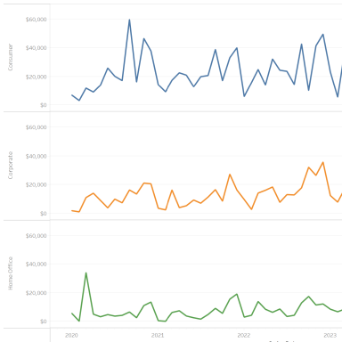

Data Sources
Data Source | Data Source Type | Source | Joins
Sample - Superstore | Live | excel-direct | [Region (Orders$)] join [Region (People)] join [Order ID (Orders$)] join [Order ID (Returns)]

Filters
Field Name | Field Selection | Selected Field Value(s) | Field Wildcard | Field Condition | Field Limit | Context Filter
Order Date | In-Range | From 2023-01-03 to 2026-12-30 | All | None | max[#2026-12-30#], min[#2023-01-03#] | No
Region | Use all |  | All | None | None | No

Marks
Object(s) Used | Mark Type
Segment | Color
Forecast Indicator | Color

Columns and Rows
Field Name | Column/Row
Segment | Rows
Sum (Sales) | Rows
Month (Order Date) | Columns

Worksheet Name: OTE

Worksheet was used in the following Dashboards
- Commission Model

Data Sources
Data Source | Data Source Type | Source | Joins
Sales Commission | Live | textscan | None

Filters
Field Name | Field Selection | Field Wildcard | Field Condition | Field Limit | Context Filter
Measure Names Sum(OTE ) | Selected from list | All | None | None | No
Measure Names Avg(OTE ) | Selected from list | All | None | None | No

Marks
Object(s) Used | Mark Type
Measure Values | Label

Calculated Fields
Field Name | Formula
Rank over 3 | ROUND(INDEX() / 3 - 0.6,0) + 1
OTE (Variable) | [Base Salary] + ([Commission Rate]*[Parameters].[New Quota])/100

Columns and Rows
Field Name | Column/Row
Measure Names | Rows

Applied Sortings
Field Name | Sort By | Sort Order | Aggregation Field | Aggregation Type
Measure Names | Manual | NA | NA | NA

Worksheet Name: Performance
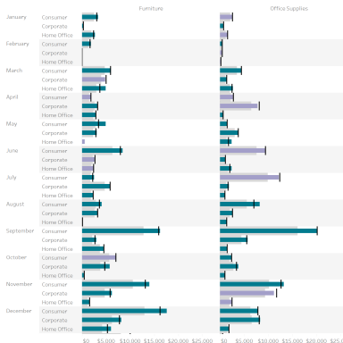

Data Sources
Data Source | Data Source Type | Source | Joins
Sample - Superstore | Live | excel-direct | [Region (Orders$)] join [Region (People)] join [Order ID (Orders$)] join [Order ID (Returns)]
Sales Target | Live | excel-direct | None

Blends
Primary Data Source | Primary DS Blended Field Name | Secondary Data Source | Secondary DS Blended Field Name
Sample - Superstore | Order Date (Month) | Sales Target | Order Date (Month)
Sample - Superstore | Category | Sales Target | Category
Sample - Superstore | Segment | Sales Target | Segment
Sample - Superstore | Order Date (Year) | Sales Target | Order Date (Year)

Filters
Field Name | Field Selection | Selected Field Value(s) | Field Wildcard | Field Condition | Field Limit | Context Filter
Region | Use all |  | All | None | None | No
Order Date | Use all |  | All | None | None | No

Marks
Object(s) Used | Mark Type
Custom (Sales above Target?) | Color
Sum (Sales Target) | Detail
Custom (SUM([Sales])-SUM([Sales Target].[Sales Target])) | Detail

Calculated Fields
Field Name | Formula
Sales above Target? | If Sum([Sales])>SUM([Sales Target].[Sales Target]) then "Above Target" else "Below Target" end

Columns and Rows
Field Name | Column/Row
Year (Order Date) | Rows
Month (Order Date) | Rows
Segment | Rows
Category | Columns
Sum (Sales) | Columns

Worksheet Name: Product Detail Sheet

Worksheet was used in the following Dashboards
- Order Details

Data Sources
Data Source | Data Source Type | Source | Joins
Sample - Superstore | Live | excel-direct | [Region (Orders$)] join [Region (People)] join [Order ID (Orders$)] join [Order ID (Returns)]

Filters
Field Name | Field Selection | Selected Field Value(s) | Field Wildcard | Field Condition | Field Limit | Context Filter
Measure Names Sum(Sales) | Selected from list |  | All | None | None | No
Measure Names Sum(Quantity) | Selected from list |  | All | None | None | No
Measure Names Sum(Discount) | Selected from list |  | All | None | None | No
Measure Names Sum(Profit) | Selected from list |  | All | None | None | No
Measure Names (Profit Ratio) | Selected from list |  | All | None | None | No
Measure Names Sum(Days to Ship Scheduled) | Selected from list |  | All | None | None | No
Measure Names Sum(Days to Ship Actual) | Selected from list |  | All | None | None | No
Action (Order Profitable?,MONTH(Order Date),Segment) | Use all |  | All | None | None | No
Action (Postal Code,State/Province) 1 | Use all |  | All | None | None | No
Category | Use all |  | All | None | None | No
City | Excluded from list | None | All | None | None | No
Order Date | Manual Selection | None | All | None | None | No
Order Date | In-Range | From 2023-01-03 to 2026-12-30 | All | None | max[#2026-12-30#], min[#2023-01-03#] | No
Region | Use all |  | All | None | None | No
Segment | Use all |  | All | None | None | No
State/Province | Use all |  | All | None | None | No

Marks
Object(s) Used | Mark Type
Measure Values | Label

Calculated Fields
Field Name | Formula
Days to Ship Actual | DATEDIFF('day',[Order Date],[Ship Date])
Days to Ship Scheduled | CASE [Ship Mode]  WHEN "Same Day" THEN 0  WHEN "First Class" THEN 1  WHEN "Second Class" THEN 3  WHEN "Standard Class" THEN 6  END
Order Profitable? | {fixed [Order ID]:sum([Profit])}>0  // calculates the profit at the order level
Profit Ratio | sum([Profit])/sum([Sales])

Columns and Rows
Field Name | Column/Row
Order ID | Rows
Customer Name | Rows
Order Date | Rows
Ship Date | Rows
Ship Mode | Rows
Measure Names | Columns

Applied Sortings
Field Name | Sort By | Sort Order | Aggregation Field | Aggregation Type
Measure Names | Manual | NA | NA | NA

Worksheet Name: ProductDetails

Worksheet was used in the following Dashboards
- Product

Data Sources
Data Source | Data Source Type | Source | Joins
Sample - Superstore | Live | excel-direct | [Region (Orders$)] join [Region (People)] join [Order ID (Orders$)] join [Order ID (Returns)]

Filters
Field Name | Field Selection | Selected Field Value(s) | Field Wildcard | Field Condition | Field Limit | Context Filter
Action (Category,YEAR(Order Date),MONTH(Order Date)) | Use all |  | All | None | None | No
Action (YEAR(Order Date),MONTH(Order Date)) | Use all |  | All | None | None | No
Action (YEAR(Order Date),MONTH(Order Date),Product Category) | Use all |  | All | None | None | No
Order Date | Use all |  | All | None | None | No
Order Date | In-Range | From 2023-01-03 to 2026-12-30 | All | None | max[#2026-12-30#], min[#2023-01-03#] | No
Region | Use all |  | All | None | None | No
Order Date | Use all |  | All | None | None | No

Marks
Object(s) Used | Mark Type
Custom (Profit Ratio) | Color
Product Name | Detail
Category | Detail
Sum (Profit) | Detail

Calculated Fields
Field Name | Formula
Profit Ratio | sum([Profit])/sum([Sales])

Columns and Rows
Field Name | Column/Row
Category | Rows
Sub-Category | Rows
Segment | Columns
Sum (Sales) | Columns

Worksheet Name: ProductView

Worksheet was used in the following Dashboards
- Product

Data Sources
Data Source | Data Source Type | Source | Joins
Sample - Superstore | Live | excel-direct | [Region (Orders$)] join [Region (People)] join [Order ID (Orders$)] join [Order ID (Returns)]

Filters
Field Name | Field Selection | Selected Field Value(s) | Field Wildcard | Field Condition | Field Limit | Context Filter
Category | Use all |  | All | None | None | No
Region | Use all |  | All | None | None | No
Order Date | Use all |  | All | None | None | No

Actions
Action Name | Source Sheet | Target Sheet | Run Action On | Target Filter
Filter Product Sales 1 | ProductView | ProductView, ProductDetails | on-select | All

Marks
Object(s) Used | Mark Type
Sum (Sales) | Color
Sum (Sales) | Label
Sum (Profit) | Tooltip

Columns and Rows
Field Name | Column/Row
Category | Rows
Year (Order Date) | Rows
Month (Order Date) | Columns

Worksheet Name: QuotaAttainment

Worksheet was used in the following Dashboards
- Commission Model

Data Sources
Data Source | Data Source Type | Source | Joins
Sales Commission | Live | textscan | None

Marks
Object(s) Used | Mark Type
Custom (% of quota achieved) | Label
Custom (Achieved Quota) | Color
New Quota | Detail
Custom (Total Compensation) | Detail
Maximum (OTE (Variable)) | Detail
Custom (Total Compensation) | Detail

Calculated Fields
Field Name | Formula
Achievement (estimated) | [Sales]
Achieved Quota | if SUM([Achievement (estimated)]) >= [New Quota] then "100% +"  elseif SUM([Achievement (estimated)]) >= 0.75 * [New Quota] then "75-100%"  elseif SUM([Achievement (estimated)]) >= 0.5 * [Parameters].[New Quota] then "50-75%"  else "Below 50%" end
Base (Variable) | [Base Salary]
% of quota achieved | AVG([Achievement (estimated)])/[New Quota]
Rank over 3 | ROUND(INDEX() / 3 - 0.6,0) + 1
Sort by field | if [Sort by]="Names" then 0  elseif [Sort by]="% quota descending" then -[% of quota achieved]  else [% of quota achieved] end
Commission (Variable) | ([Commission Rate]*[Sales])/100
OTE (Variable) | [Base Salary] + ([Commission Rate]*[Parameters].[New Quota])/100
Total Compensation | MIN([Base (Variable)]) + SUM([Commission (Variable)])

Columns and Rows
Field Name | Column/Row
Custom (Rank over 3) | Rows
Sales Person | Rows
Sum (Achievement (estimated)) | Columns

Applied Sortings
Field Name | Sort By | Sort Order | Aggregation Field | Aggregation Type
Sales Person | Field | Ascending | Sort by field | Custom
Achieved Quota | Manual | NA | NA | NA

Worksheet Name: Sale Map

Worksheet was used in the following Dashboards
- Overview

Data Sources
Data Source | Data Source Type | Source | Joins
Sample - Superstore | Live | excel-direct | [Region (Orders$)] join [Region (People)] join [Order ID (Orders$)] join [Order ID (Returns)]

Filters
Field Name | Field Selection | Selected Field Value(s) | Field Wildcard | Field Condition | Field Limit | Context Filter
Order Profitable? | Selected from list | false, true | All | None | None | No
Order Date | In-Range | From 2023-01-03 to 2026-12-30 | All | None | max[#2026-12-30#], min[#2023-01-03#] | No
Region | Use all |  | All | None | None | No
Profit Ratio | In-Range | From -0.22 to 0.37 | All | None | None | No

Actions
Action Name | Source Sheet | Target Sheet | Run Action On | Target Filter
State/Province Filter 1 | Sale Map | Total Sales, Sales by Segment, Sales by Product | on-select | Selected (State/Province)
State/Province Highlight (map) 1 | Total Sales, Sale Map | Total Sales, Sale Map | on-select | Selected (State/Province)

Marks
Object(s) Used | Mark Type
Custom (Profit Ratio) | Color
State/Province | Detail
Country/Region | Detail
Tooltip: Profit Ratio by City | Viz in Tooltip

Calculated Fields
Field Name | Formula
Order Profitable? | {fixed [Order ID]:sum([Profit])}>0  // calculates the profit at the order level
Profit Ratio | sum([Profit])/sum([Sales])

Columns and Rows
Field Name | Column/Row
Latitude (generated) | Rows
Longitude (generated) | Columns

Worksheet Name: Sales

Worksheet was used in the following Dashboards
- Commission Model

Data Sources
Data Source | Data Source Type | Source | Joins
Sales Commission | Live | textscan | None

Filters
Field Name | Field Selection | Field Wildcard | Field Condition | Field Limit | Context Filter
Measure Names Sum(Sales) | Selected from list | All | None | None | No
Measure Names (% of quota achieved) | Selected from list | All | None | None | No

Marks
Object(s) Used | Mark Type
Measure Values | Label

Calculated Fields
Field Name | Formula
Achievement (estimated) | [Sales]
% of quota achieved | AVG([Achievement (estimated)])/[New Quota]

Columns and Rows
Field Name | Column/Row
Measure Names | Rows

Applied Sortings
Field Name | Sort By | Sort Order | Aggregation Field | Aggregation Type
Measure Names | Manual | NA | NA | NA

Worksheet Name: Sales by Product

Worksheet was used in the following Dashboards
- Overview

Data Sources
Data Source | Data Source Type | Source | Joins
Sample - Superstore | Live | excel-direct | [Region (Orders$)] join [Region (People)] join [Order ID (Orders$)] join [Order ID (Returns)]

Filters
Field Name | Field Selection | Selected Field Value(s) | Field Wildcard | Field Condition | Field Limit | Context Filter
Action (MONTH(Order Date),Segment) | Use all |  | All | None | None | No
Action (Postal Code,State/Province) | Use all |  | All | None | None | No
Action (State/Province) | Use all |  | All | None | None | No
Order Profitable? | Selected from list | false, true | All | None | None | No
Order Date | In-Range | From 2023-01-03 to 2026-12-30 | All | None | max[#2026-12-30#], min[#2023-01-03#] | No
Region | Use all |  | All | None | None | No

Actions
Action Name | Source Sheet | Target Sheet | Run Action On | Target Filter
Month Highlight 1 | Total Sales, Sales by Segment, Sales by Product | Total Sales, Sales by Segment, Sales by Product | on-select | Selected (MONTH(Order Date),Order Profitable?)

Marks
Object(s) Used | Mark Type
Order Profitable? | Color
Sum (Profit) | Tooltip

Calculated Fields
Field Name | Formula
Order Profitable? | {fixed [Order ID]:sum([Profit])}>0  // calculates the profit at the order level

Columns and Rows
Field Name | Column/Row
Category | Rows
Sum (Sales) | Rows
Month (Order Date) | Columns

Applied Sortings
Field Name | Sort By | Sort Order | Aggregation Field | Aggregation Type
Order Profitable? | Manual | NA | NA | NA

Worksheet Name: Sales by Segment

Worksheet was used in the following Dashboards
- Overview

Data Sources
Data Source | Data Source Type | Source | Joins
Sample - Superstore | Live | excel-direct | [Region (Orders$)] join [Region (People)] join [Order ID (Orders$)] join [Order ID (Returns)]

Filters
Field Name | Field Selection | Selected Field Value(s) | Field Wildcard | Field Condition | Field Limit | Context Filter
Action (MONTH(Order Date),Product Category) | Use all |  | All | None | None | No
Action (Postal Code,State/Province) | Use all |  | All | None | None | No
Action (State/Province) | Use all |  | All | None | None | No
Order Profitable? | Selected from list | false, true | All | None | None | No
Order Date | In-Range | From 2023-01-03 to 2026-12-30 | All | None | max[#2026-12-30#], min[#2023-01-03#] | No
Region | Use all |  | All | None | None | No

Actions
Action Name | Source Sheet | Target Sheet | Run Action On | Target Filter
Month Highlight 1 | Total Sales, Sales by Segment, Sales by Product | Total Sales, Sales by Segment, Sales by Product | on-select | Selected (MONTH(Order Date),Order Profitable?)

Marks
Object(s) Used | Mark Type
Order Profitable? | Color
Sum (Profit) | Tooltip

Calculated Fields
Field Name | Formula
Order Profitable? | {fixed [Order ID]:sum([Profit])}>0  // calculates the profit at the order level

Columns and Rows
Field Name | Column/Row
Segment | Rows
Sum (Sales) | Rows
Month (Order Date) | Columns

Applied Sortings
Field Name | Sort By | Sort Order | Aggregation Field | Aggregation Type
Order Profitable? | Manual | NA | NA | NA

Worksheet Name: ShipSummary

Worksheet was used in the following Dashboards
- Shipping

Data Sources
Data Source | Data Source Type | Source | Joins
Sample - Superstore | Live | excel-direct | [Region (Orders$)] join [Region (People)] join [Order ID (Orders$)] join [Order ID (Returns)]

Filters
Field Name | Field Selection | Selected Field Value(s) | Field Wildcard | Field Condition | Field Limit | Context Filter
Ship Status | Use all |  | All | None | None | No
Region | Use all |  | All | None | None | No
Ship Mode | Use all |  | All | None | None | No
Order Date | Selected from list | Q4 | All | None | None | No
Order Date | Selected from list | 2026 | All | None | None | No

Actions
Action Name | Source Sheet | Target Sheet | Run Action On | Target Filter
Filter 1 (generated) 1 | ShipSummary | ShipSummary, ShippingTrend, DaystoShip | on-select | All

Marks
Object(s) Used | Mark Type
Ship Status | Color
Count (Orders) | Label
Ship Status | Label

Calculated Fields
Field Name | Formula
Days to Ship Actual | DATEDIFF('day',[Order Date],[Ship Date])
Ship Status | if [Days to Ship Actual]> [Days to Ship Scheduled] then "Shipped Late"  elseIF [Days to Ship Actual]= [Days to Ship Scheduled] then "Shipped On Time"  Else "Shipped Early" end
Days to Ship Scheduled | CASE [Ship Mode]  WHEN "Same Day" THEN 0  WHEN "First Class" THEN 1  WHEN "Second Class" THEN 3  WHEN "Standard Class" THEN 6  END

Columns and Rows
Field Name | Column/Row
Count (Orders) | Columns

Applied Sortings
Field Name | Sort By | Sort Order | Aggregation Field | Aggregation Type
Ship Status | Manual | NA | NA | NA

Worksheet Name: ShippingTrend

Worksheet was used in the following Dashboards
- Shipping

Data Sources
Data Source | Data Source Type | Source | Joins
Sample - Superstore | Live | excel-direct | [Region (Orders$)] join [Region (People)] join [Order ID (Orders$)] join [Order ID (Returns)]

Filters
Field Name | Field Selection | Selected Field Value(s) | Field Wildcard | Field Condition | Field Limit | Context Filter
Action (Delayed?) | Use all |  | All | None | None | No
Action (Ship Status) | Use all |  | All | None | None | No
Region | Use all |  | All | None | None | No
Ship Mode | Use all |  | All | None | None | No
Order Date | Selected from list | Q4 | All | None | None | No
Order Date | Selected from list | 2026 | All | None | None | No

Actions
Action Name | Source Sheet | Target Sheet | Run Action On | Target Filter
Filter Details 1 | ShippingTrend | ShippingTrend, DaystoShip | on-select | All

Marks
Object(s) Used | Mark Type
Ship Status | Color

Calculated Fields
Field Name | Formula
Days to Ship Actual | DATEDIFF('day',[Order Date],[Ship Date])
Ship Status | if [Days to Ship Actual]> [Days to Ship Scheduled] then "Shipped Late"  elseIF [Days to Ship Actual]= [Days to Ship Scheduled] then "Shipped On Time"  Else "Shipped Early" end
Days to Ship Scheduled | CASE [Ship Mode]  WHEN "Same Day" THEN 0  WHEN "First Class" THEN 1  WHEN "Second Class" THEN 3  WHEN "Standard Class" THEN 6  END

Columns and Rows
Field Name | Column/Row
Count (Orders) | Rows
Year (Order Date) | Columns
Week (Order Date) | Columns

Applied Sortings
Field Name | Sort By | Sort Order | Aggregation Field | Aggregation Type
Ship Status | Manual | NA | NA | NA

Worksheet Name: Tooltip: Profit Ratio by City

Data Sources
Data Source | Data Source Type | Source | Joins
Sample - Superstore | Live | excel-direct | [Region (Orders$)] join [Region (People)] join [Order ID (Orders$)] join [Order ID (Returns)]

Filters
Field Name | Field Selection | Selected Field Value(s) | Field Wildcard | Field Condition | Field Limit | Context Filter
Tooltip (Country/Region,State/Province) | Use all |  | All | None | None | No
Tooltip (State/Province) | Use all |  | All | None | None | No
Order Date | In-Range | From 2023-01-03 to 2026-12-30 | All | None | max[#2026-12-30#], min[#2023-01-03#] | No

Marks
Object(s) Used | Mark Type
Custom (Profit Ratio) | Color

Calculated Fields
Field Name | Formula
Profit Ratio | sum([Profit])/sum([Sales])

Applied Sortings
Field Name | Sort By | Sort Order | Aggregation Field | Aggregation Type
City | Field | Ascending | Profit Ratio | Custom

Worksheet Name: Total Sales

Worksheet was used in the following Dashboards
- Overview

Data Sources
Data Source | Data Source Type | Source | Joins
Sample - Superstore | Live | excel-direct | [Region (Orders$)] join [Region (People)] join [Order ID (Orders$)] join [Order ID (Returns)]

Filters
Field Name | Field Selection | Selected Field Value(s) | Field Wildcard | Field Condition | Field Limit | Context Filter
Measure Names Sum(Sales) | Selected from list |  | All | None | None | No
Measure Names Sum(Profit) | Selected from list |  | All | None | None | No
Measure Names (Profit Ratio) | Selected from list |  | All | None | None | No
Measure Names (Sales per Customer ) | Selected from list |  | All | None | None | No
Measure Names (Sales per Customer) | Selected from list |  | All | None | None | No
Measure Names Avg(Discount) | Selected from list |  | All | None | None | No
Measure Names Sum(Quantity) | Selected from list |  | All | None | None | No
Action (Order Profitable?,Category,MONTH(Order Date)) | Use all |  | All | None | None | No
Action (Order Profitable?,MONTH(Order Date),Segment) | Use all |  | All | None | None | No
Action (State/Province) | Use all |  | All | None | None | No
Order Date | In-Range | From 2023-01-03 to 2026-12-30 | All | None | max[#2026-12-30#], min[#2023-01-03#] | No
Region | Use all |  | All | None | None | No

Actions
Action Name | Source Sheet | Target Sheet | Run Action On | Target Filter
State/Province Highlight (map) 1 | Total Sales, Sale Map | Total Sales, Sale Map | on-select | Selected (State/Province)
Month Highlight 1 | Total Sales, Sales by Segment, Sales by Product | Total Sales, Sales by Segment, Sales by Product | on-select | Selected (MONTH(Order Date),Order Profitable?)

Marks
Object(s) Used | Mark Type
Measure Values | Label

Calculated Fields
Field Name | Formula
Sales Forecast | [Sales]*(1-[Churn Rate])*(1+[New Business Growth])
Order Profitable? | {fixed [Order ID]:sum([Profit])}>0  // calculates the profit at the order level
Sales per Customer | Sum([Sales])/countD([Customer Name])
Profit Ratio | sum([Profit])/sum([Sales])
Units estimate | ROUND([Quantity]*(1-[Churn Rate])*(1+[New Business Growth]),0)
Profit per Order | Sum([Profit])/countD([Order ID])

Columns and Rows
Field Name | Column/Row
Measure Names | Columns

Applied Sortings
Field Name | Sort By | Sort Order | Aggregation Field | Aggregation Type
Measure Names | Manual | NA | NA | NA

Worksheet Name: What If Forecast
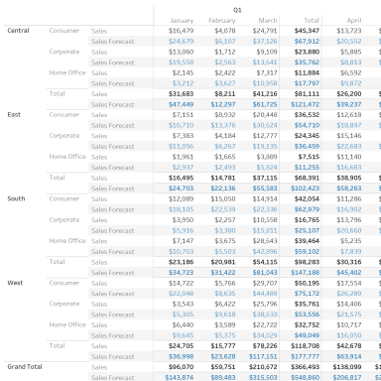

Data Sources
Data Source | Data Source Type | Source | Joins
Sample - Superstore | Live | excel-direct | [Region (Orders$)] join [Region (People)] join [Order ID (Orders$)] join [Order ID (Returns)]

Filters
Field Name | Field Selection | Selected Field Value(s) | Field Wildcard | Field Condition | Field Limit | Context Filter
Measure Names Sum(Sales) | Selected from list |  | All | None | None | No
Measure Names Sum(Sales Forecast) | Selected from list |  | All | None | None | No
Order Date | In-Range | From 2023-01-03 to 2026-12-30 | All | None | max[#2026-12-30#], min[#2023-01-03#] | No
Region | Use all |  | All | None | None | No
Order Date | Use all |  | All | None | None | No

Marks
Object(s) Used | Mark Type
Measure Names | Color
Measure Values | Label
Custom (SUM([Sales])-SUM([Sales Forecast])) | Detail
Sum (Sales) | Detail
Sum (Sales Forecast) | Detail

Calculated Fields
Field Name | Formula
Sales Forecast | [Sales]*(1-[Churn Rate])*(1+[New Business Growth])

Columns and Rows
Field Name | Column/Row
Region | Rows
Segment | Rows
Measure Names | Rows
Quarter (Order Date) | Columns
Month (Order Date) | Columns

Applied Sortings
Field Name | Sort By | Sort Order | Aggregation Field | Aggregation Type
Measure Names | Manual | NA | NA | NA

